Title: | NextCloud Cloud Storage Server
Updated: | April 17, 2025 | Due Date: | Midnight before the next class meeting.
Purpose: | You will install and set up a self-hosted NextCloud server on a Linux platform. This exercise aims to provide hands-on experience with cloud storage solutions that users manage, contrasting with commercial cloud services. It focuses on building technical skills in server setup, network configuration, and the deployment of NextCloud, emphasizing the benefits and responsibilities of hosting one's cloud storage solution.
Knowledge: | Installing software, configuring services, and researching requirements for a specific piece of software.
Task/Activity: | A. Install Linux  B. Setup PuTTY to Connect  C. Install Server Services  D. Use NextCloud  E. Reflection
Criteria for Success: | Success in this lab is marked by accurate task completion, effective analysis, documentation, and clear communication of findings. A crucial aspect involves reflecting on the purpose of the lab, linking procedures to broader concepts, and recognizing the lab's significance within the course.  Overall, success is not only measured by technical proficiency but also by critical thinking, effective communication, and a reflective summary that captures the challenges faced and insights gained throughout the lab experience.
- Install Linux
- We will need a Linux machine to build on. Create an AWS server with the following settings:
- Name: NextCloud Storage Project
- Linux Red Hat Enterprise Linux 9
- 50GB Storage
- T2.medium instance size
- Generate a new key called NextCloud
- Setup PuTTY to Connect
- Configure PuTTY (or the SSH client of your choice). Submit a screenshot (or shots if there are multiple pages/tabs of configuration) below.
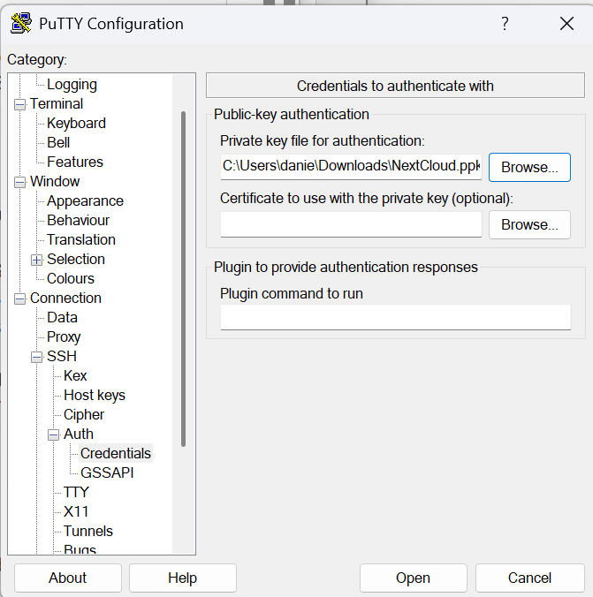
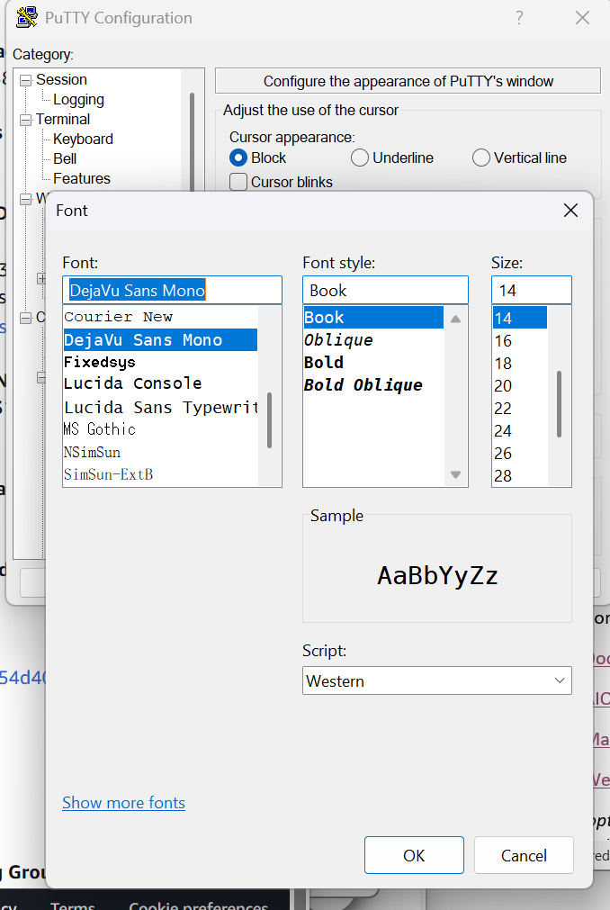
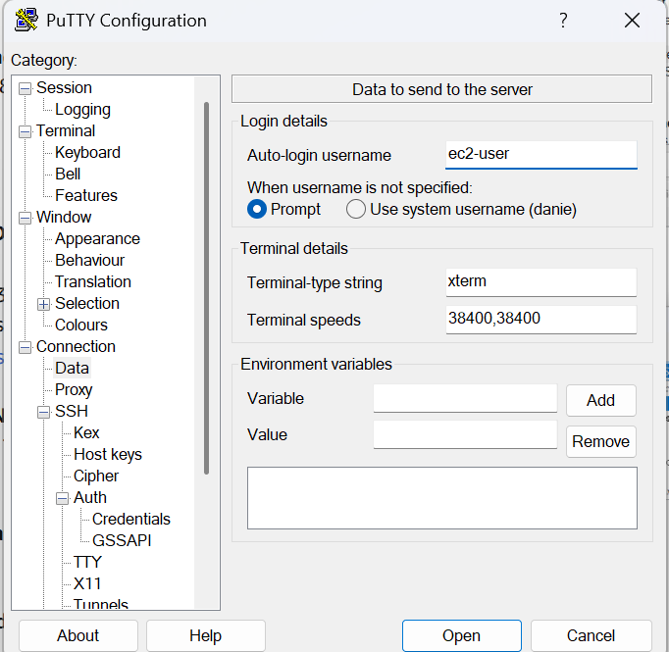
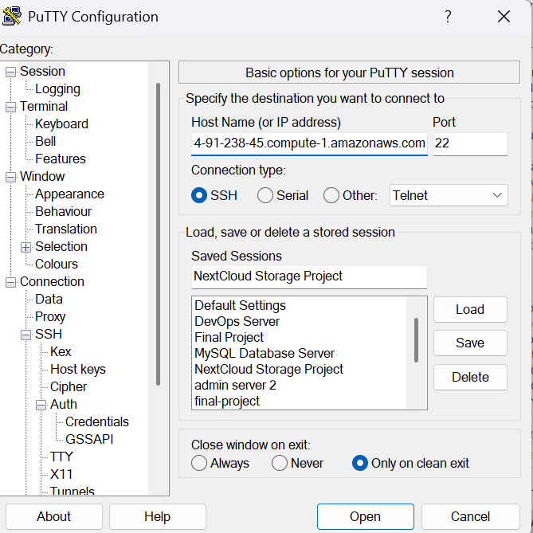
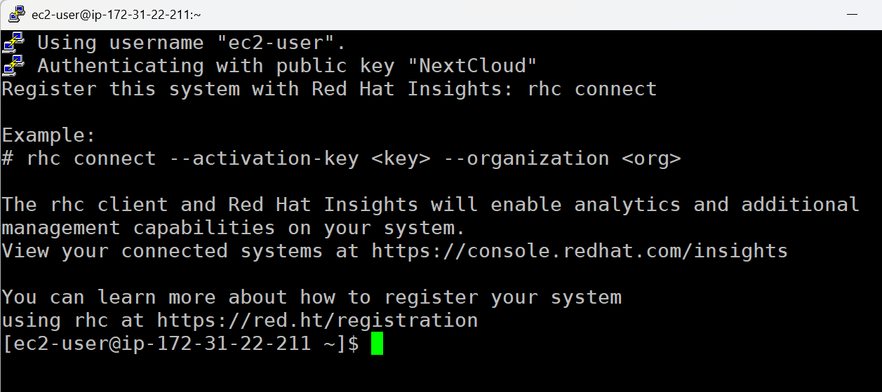
- Install Server Services
NextCloud is a cloud storage solution, similar to OneDrive, Good Drive, Dropbox, and other cloud storage services, but hosted by you. There are a lot of options with NextCloud such as online document editing similar to Office Online or Google Docs.
There are a lot of different ways to install NextCloud. This particular lab is going to give you the option on how to install it. You can install it manually with the commands and instructions on the NextCloud documentation site, install and utilize Docker, a container system that makes installing and running software pretty easy, or using the web installer that they have.
NextCloud Documentation Site
NextCloud AIO (All in One) Docker Instructions
NextCloud Manual Installation
NextCloud Web Installer
Note: Each option has it’s own pros and cons. While the web installer may be the easiest, you need to have a working Apache install with MySQL (or MariaDB), PHP (with all the required modules), and anything else. The Docker route could be easier, but Docker will need to be installed and running (which we have not covered in class).
- What method are you going to use to install NextCloud and why?
I chose the method of the manual installation after careful review of the other methods provided. Initially I wanted to use the Docker method, but it was a bit more confusing to me. The manual was a method that I felt would explain the installation process in a way that would make me feel more confident in.
- What are the commands that you used to get NextCloud running? This should allow anyone to run these commands and get a fully working installation after. If you are missing any commands to get it working, this will be marked incorrect. Include all permissions commands, service install commands, systemctl commands, etc.
sudo su
dnf install wget -y
dnf install \https://dl.fedoraproject.org/pub/epel/epel-release-latest-9.noarch.rpm
dnf install -y epel-release yum-utils unzip curl wget \
bash-completion policycoreutils-python-utils mlocate bzip2
dnf update -y
dnf install -y httpd
systemctl enable httpd
systemctl start httpd
dnf install https://rpms.remirepo.net/enterprise/remi-release-9.rpm
dnf install yum-utils
dnf module reset php
dnf module install php:remi-8.2
dnf install -y php php-cli php-gd php-mbstring php-intl php-pecl-apcu\
php-mysqlnd php-opcache php-json php-zip
dnf install -y mariadb mariadb-server
systemctl enable mariadb.service
systemctl start mariadb.service
mysql_secure_installation
dnf install -y redis
systemctl enable redis.service
systemctl start redis.service
wget https://download.nextcloud.com/server/releases/nextcloud-27.1.6.tar.bz2.asc
wget https://download.nextcloud.com/server/releases/nextcloud-27.1.6.tar.bz2
wget https://nextcloud.com/nextcloud.asc
gpg --import nextcloud.asc
gpg --verify nextcloud-27.1.6.tar.bz2.asc nextcloud-27.1.6.tar.bz2
tar -xvjf nextcloud-27.1.6.tar.bz2
cp -R nextcloud/ /var/www/html/
mkdir /var/www/html/nextcloud/data
chown -R apache:apache /var/www/html/nextcloud
systemctl restart httpd.service
dnf install firewalld -y
systemctl enable firewalld
systemctl start firewalld
firewall-cmd --zone=public --add-service=http --permanent
firewall-cmd --reload
dnf install vim -y
vim /etc/httpd/conf.d/nextcloud.conf
- Change the server to the website or link you need
cd /var/www/html/
cd nextcloud
cd config
vim /etc/selinux/config
- Change selinux from enforced to disabled

- Once you have successfully browsed to your NextCloud instance, login and provide a screenshot below.
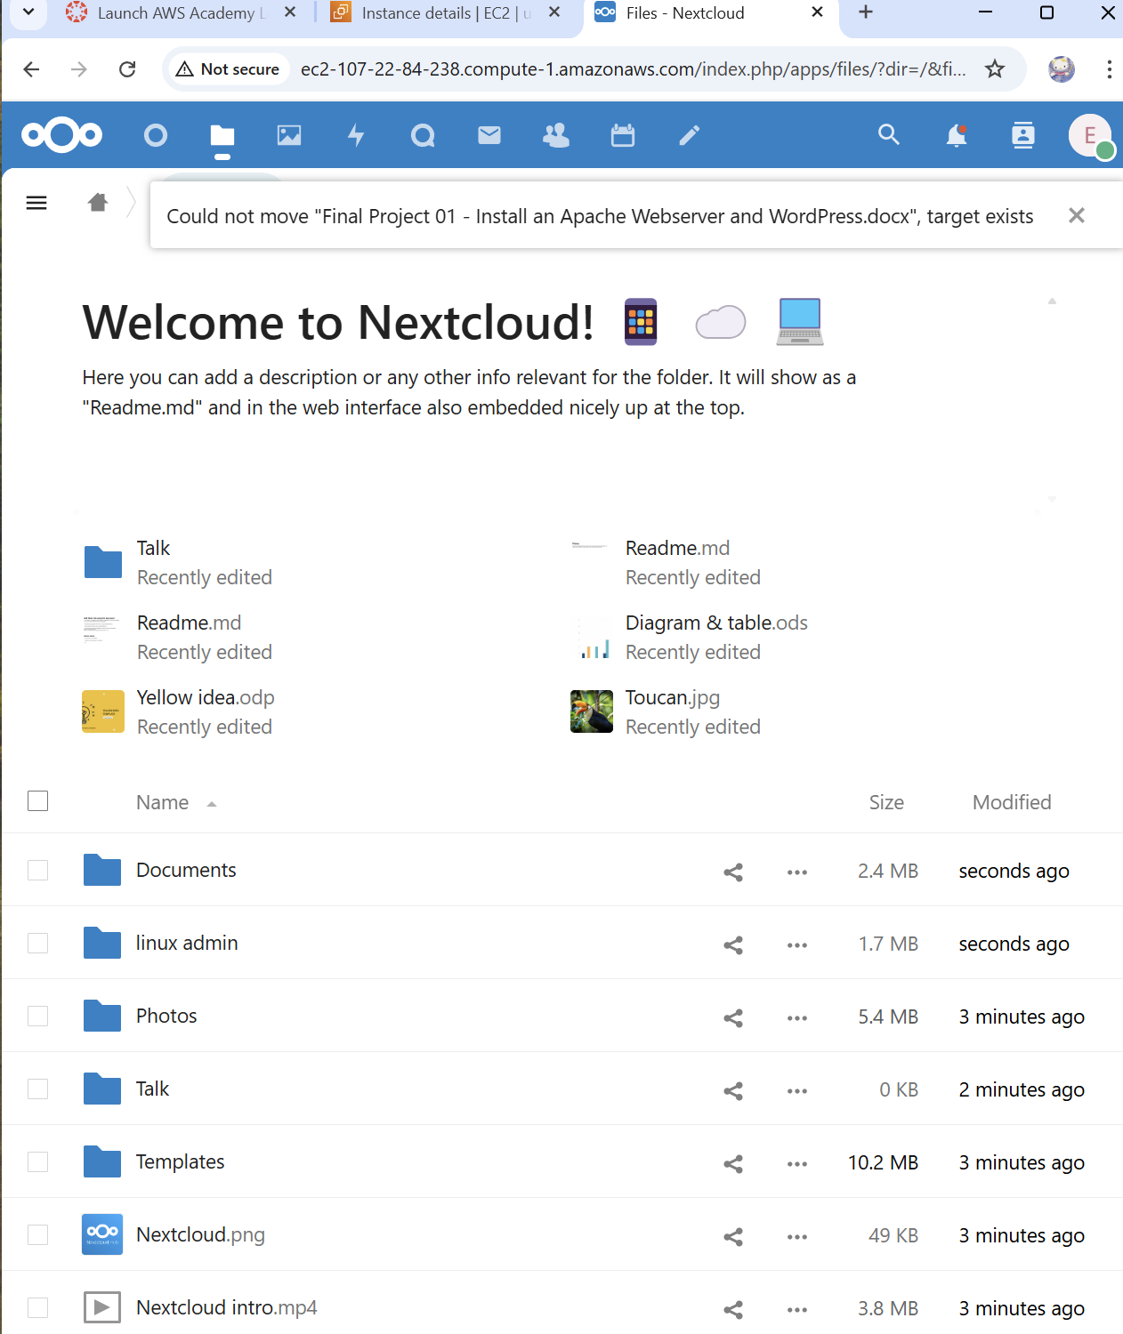
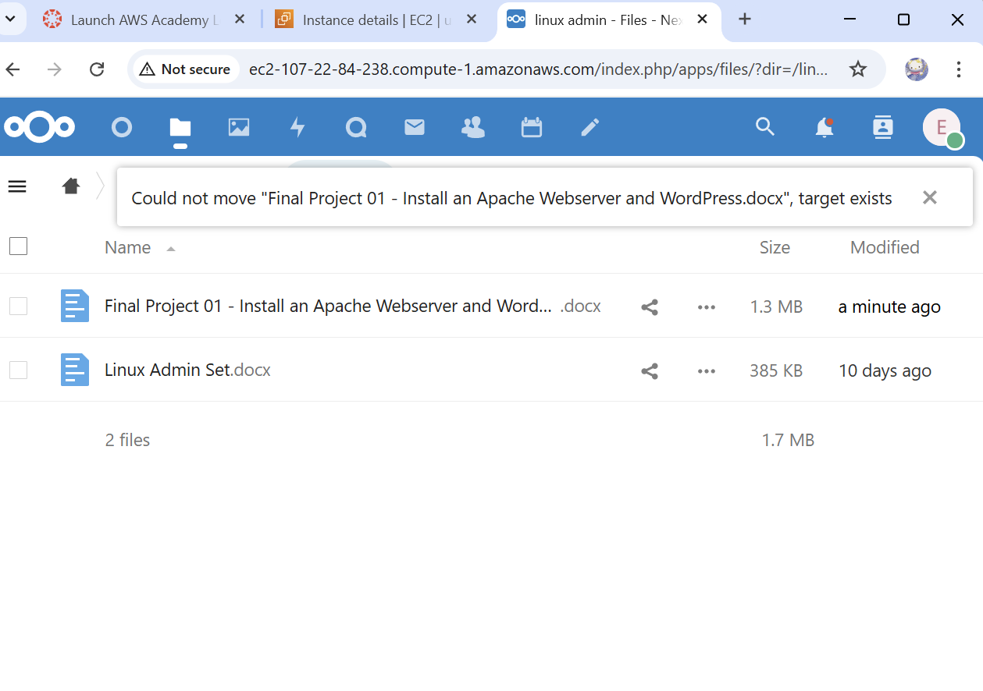
- Use NextCloud
Now that you have a running NextCloud instance, create a folder or two, and some files. Play around with the settings. Note anything interesting that you came across.
- Is this a project that you can see use in? What are the advantages of using this instead of a major cloud provider?
I like the versatility of the application of this web installer, it was very interesting to see all of the options of how to install this installer. I can’t speak confidently about the major advantages of NextCloud specifically, but I do know that it has the capacity to match most major providers. In my humble opinion this web installer offers a good amount of flexibility in its uses and can be personalized to the user while maintaining a good level of security.

I just know that I would feel relieved to use this method of installing if I were to need it in my professional career.
- Reflection
The steps that you completed are very useful in installing any major piece of software on Linux, especially complex software like NextCloud. Utilizing a server like this on hardware that you control could be beneficial to you or your organization. There are also some downfalls. If the server goes down, you are responsible for it. Any data loss is on you and not a cloud service provider. However, only you and those you provide access to, can access the files and folders stored on this system, away from prying eyes. This also provides a smaller chance that you will be targeted for a data breach attack.
What did you find most challenging in this project? What was easy? Tell me about your experience completing this project.
As I was progressing through this project I was advancing smoothly, unfortunately I hit a major snag that I just couldn’t solve on my own. I managed to get to the Nextcloud web installer screen, but I faced an error with the installer not reading my config files. I deleted and relaunched my instances like 3 times to check which step I messed up on before I reached out to my professor for help. I tried changing the permissions several times and more and still received an error. After discussing it with the professor we figured out the issue, and thankfully it was a simple solution that involved disabling the selinux in the config file. I really enjoy the process of completing this final project, again the satisfaction of accomplishing this task and seeing the login page instead of the errors I was receiving. Then when I was finally able to play around with the nextcloud web service it was fun to see the unique aspects of the system. It was not easy but its was extremely gratifying to complete it.

